CS 300 Project 1 – Database Design Project
Project Goal: To design and implement a small relational database from requirements document all the way to SQL code using the Entity-Relationship Model, logical schema translation, and MySQL.
Instructions: Choose one of the three narratives below that interest you, from which you will create and implement a relational database. After selection, you should follow the steps outlined in the Design and Implementation section below.
Narratives:
- A famous Greek shipping magnate, Stell, owns many container ships. Containers are collected at one port and delivered to another port. Customers pay a negotiated fee for the delivery of each container. Each ship has a sailing schedule that lists the ports the ship will visit over the next six months. The schedule shows the expected arrival and departure dates. The daily charge for the use of the port is also recorded.
- A real estate investment company owns many shopping malls. Each mall contains many shops. To encourage rental of its shops, the company gives a negotiated discount to retailers who have shops in more than one mall. Each shop generated an income stream that can vary from month to month because rental is based on a flat rental charge and a negotiated percent of sales revenue. Also, each shop has monthly expenses for scheduled and unscheduled maintenance. The company uses the data to compute its monthly net income per square meter for each shop and for ad hoc querying.
- Steve operates a cinema chain and has given you the following information: “I have many cinemas. Each cinema can have multiple theaters. Movies are shown through the day starting at 11:00AM and finishing at 1:00AM. Each movie is given a two-hour time slot. We never show a movie in more than one theater at a time, but we do shift movies among theaters because seating capacity varies. I am interested in knowing how many people, classified by adults and children attended each showing a movie. I vary ticket prices by movie and time slot. For instance, “Lassie Get Lost” is 50 cents for everyone at 11:00AM but is 75 cents at 11:00PM.

Once your narrative is selected, you will follow the steps below to generate i. a requirements document, ii. entity-relationship model diagram, iii. logical schema, and iv. MySQL code to implement the resulting database, all of which you will submit.
Design and Implementation
- After selecting a narrative, your first design step should be to create a requirements document that clearly emphasizes entities and relationships (ex: by using capitalization, boldface, italicization, or underlining). You will very likely want to follow the approach taken on slide 3 of Session 15, and note that the narratives have been intentionally left with gaps that you will want to address. As none of us are presumably experts regarding the given narratives, I will be extremely flexible regarding how your write your requirements document, but the following requirements will be enforced:
- You must have a minimum of four entities and four relationships. (It is certainly alright to have more, but this represents the minimum).
- You must specify a uniqueness criterion of your own choosing for each entity in your requirements document. (Ex: “Each container is uniquely identified by a 10-character serial number.”)
- As per step 2 below, there must be at least one Many-to-many relationship in the ER diagram, so make sure you factor that into your document writing.
Narrative:
- The cinema chain is organized into CINEMAs. Each cinema will have an address of up to 250 characters, and a cinema_name of up to 180 characters, and is uniquely identified by an integer cinema_ID.
- Every cinema contains THEATERs. Each theater will have a seating_capacity which is an integer that can be up to 3 digits. Every theater will be associated with a given cinema_ID. It will be uniquely identified by a 3-character theater_number.
- Each theater will be presenting MOVIEs. Every movie will have the director_name of up to 180 characters. Each movie will be uniquely identified by a combination of the movie_name which can be up to 250 characters and a time_slot in time format. The year the movie was released is a year datetime release_year. Every movie will also have a movie_rating which can be integers 0, 1, 2, 3, 4, 5 with 5 being the highest rating. Every movie will be in a specific theater_num at a given time. Every movie will have showtime which the price of the TICKET depends on.
- Every movie is watched by PEOPLE. Each person is classified by their birthdate called bdate which is a date. These birthdates are specified by a 5-character age_group where a person is either a “adult” if 18 or older or a “child” if below the age of 18. Each person saw a movie based on the movie_name and the time_slot. Each person has a 2-character seat_number. Each person can be classified based on whether they are an awards_member which is 6 characters. So, a person can either be a ‘Golden’, ‘Silver,’ member or null if they are not a member. Each person is uniquely identified by their email which can be up to 255 characters. We assume no two people can have the same email.
- Every person paid for a TICKET. Each ticket has a ticket_price which is a currency in decimal form with a maximum of 10 digits and can never be negative. The ticket_price for a movie is determined by the movie_name and time_slot for that movie. A person who purchases a ticket is identified by their email. The ticket for a given movie is uniquely identified by a ticket_price_index which can be up to 3 characters.
Max-Cardinality Constraints:
- CINEMA to THEATER has a 1 to Many ratio (1:N ratio) since a cinema can have many theaters, but a theater is in one cinema not multiple cinemas at once.
- THEATER to MOVIE has a 1 to 1 ratio (1:1 ratio) since a movie can be shown in one theater for a given time slot and a theater can present one movie for a given time slot.
- PEOPLE to TICKET has a 1 to Many ratio (1:M ratio) since a person can pay for multiple tickets, but a specific ticket can only be bought by one person.
- MOVIE to TICKET has a 1 to 1 ratio (1:1 ratio) since the price of a ticket depends on a single showtime for the associated movie and the showtime of movie is associated with a single ticket price.
- PEOPLE to MOVIE has a Many to Many ratio (M:N ratio) since a person can see many movies at different time slots and a movie can be seen by many people at different time slots.

- Your next step is to use the required document to design and draw an entity-relationship model diagram for your chosen narrative. As per 1iii above, at least one of your relationships must be many-to-many (M:N). You may either manually draw and scan your diagram (Sessions 15-16 provide a good template), or you may use a tool (ex: Visio) to assist in the process. Note: if you design a UML diagram and/or design tool be certain that entities, relationships, attributes, and relationship cardinality are clearly defined within the diagram you submit. Some of these tools do not explicitly name relationships or make cardinalities clear.

CINEMA CHAIN ER Model Diagram:
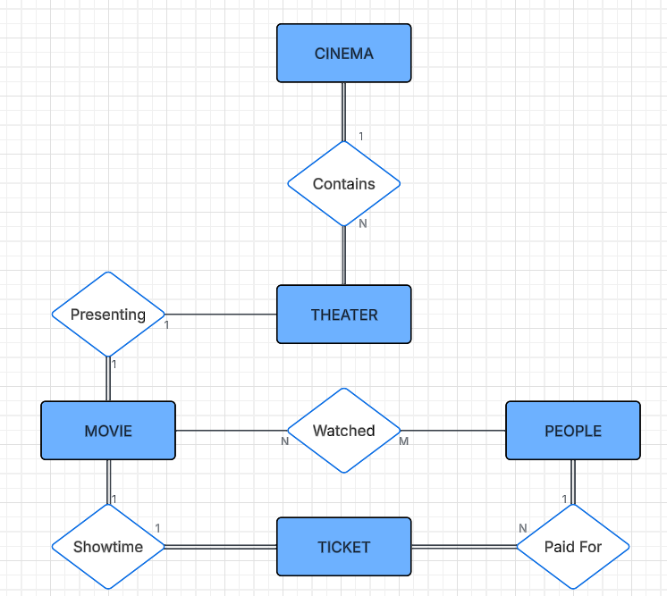
- Following the steps outlined in Session 16, you should translate your entity-relationship model diagram into a logical schema.
ER-to-Relational Mapping Algorithm:
- Step 1: Mapping of Regular (Strong) Entity Types
  - CINEMA(address, cinema_name, cinema_ID) is a strong entity
  - THEATER(seating_capacity, cinema_ID, theater_number) is a strong entity
  - MOVIE(director_name, movie_name, time_slot, release_year, movie_rating, theater_num) is a strong entity
  - PEOPLE(bdate, age_group, movie_name, time_slot, seat_number, awards_member, email) is a strong entity
  - TICKET(ticket_price, movie_name, time_slot, email, ticker_price_index) is a strong entity
- Step 2: Mapping of Weak Entity Types is a weak entity
  - There are no weak entities in this ER Model Diagram.
- Step 3: Mapping of Binary 1:1 Relationship Types
  - The MOVIE and THEATER entities each become relations. The attribute theater_num in MOVIE must reference a valid theater_number in THEATER. So, theater_num is a foreign key in the MOVIE relation while theater_number is a primary key in the THEATER relation.
  - The TICKET entity becomes a relation. The attributes movie_name, release_year, and time_slot in TICKET must reference a valid movie_name, release_year, and time_slot in MOVIE. So, movie_name, release_year, and time_slot form a foreign key in TICKET while movie_name, release_year, and time_slot form a composite primary key in MOVIE.
- Step 4: Mapping of Binary 1:N Relationship Types
  - The CINEMA entity becomes a relation. The attitude cinema_ID in THEATER must reference a valid cinema_ID in CINEMA. So, cinema_ID is a foreign key in the THEATER relation while cinema_ID is a primary key for the CINEMA relation.
  - The PEOPLE entity becomes a relation. The attribute email in TICKET must reference a valid email in PEOPLE. Therefore, email is a foreign key in the TICKET relation while email is the primary key in the PEOPLE relation.
- Step 5: Mapping of Binary M:N Relationship Types
  - The relationship between MOVIE and PEOPLE called Watched will now become a relation called WATCHED.
    - The WATCHED relation will have the attribute email which must reference a valid email in the PEOPLE relation. Therefore, email will be a foreign key for WATCHED.
    - The WATCHED relation will also have the attributes mov_name and time_slot which must reference the valid attributes movie_name and time_slot in MOVIE respectively. Therefore, mov_name and time_slot will be a foreign key for WATCHED.
    - The WATCHED relation will be uniquely identified by the composite primary key, email, mov_name, and time_slot.
    - The WATCHED relation will also have the attribute num_watched which is an integer and refers to the number of times a movie was watched by a person.
    - To ensure that PEOPLE will be a purely demographic relation, we will remove the attributes movie_name, time_slot, and seat_number. Instead, the WATCHED table will have these attributes. However, seat_number will be removed since the seat numbers do not need to be tracked.
    - WATCHED (mov_name, time_slot, email, num_watched)
    - PEOPLE(bdate, age_group, awards_member, email)
- Step 6: Mapping of Multivalued attributes
  - There are no multivalued attributes in this ER Model Diagram

Updated CINEMA CHAIN Relations and Attributes:
- CINEMA(address, cinema_name, cinema_ID)
- THEATER(seating_capacity, cinema_ID, theater_number)
- MOVIE(director_name, movie_name, time_slot, release_year, movie_rating, theater_num)
- PEOPLE(bdate, age_group, awards_member, email)
- TICKET(ticket_price, movie_name, time_slot, email, ticker_price_index)
- WATCHED (mov_name, time_slot, email, num_watched)
CINEMA CHAIN Relational Diagram Schema
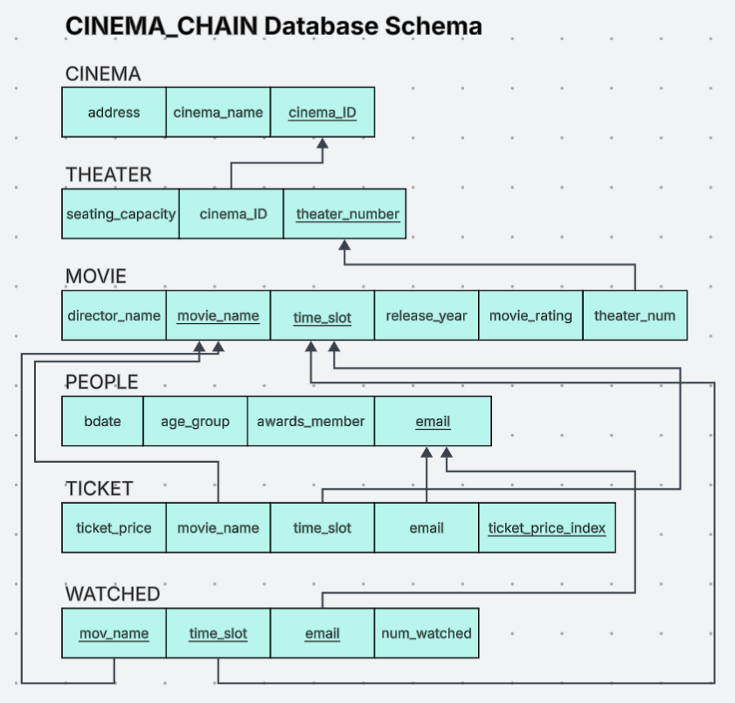
- Lastly, you should follow the steps taken early in the semester to generate suitable MySQL data definition code for your logical schema.
